Smart Farm - Automatic Plant Watering system with message alert

R.Anirudh Reddy , M. Srilekha Jyothi Yadav

Faculty in Electronics and Student in Electronics and Student in Electronics and

Communication engineering(ECE) Communication Engineering(ECE) Communication Engineering(ECE)

*BV Raju institute of technology,Medak, BV Raju institute of technology,Medak BV Raju institute of technology,Medak*

*Narsapur,Telangana,India Narsapur,Telangana,India Narsapur,Telangana,India*

anirudhreddy.r@bvrit.ac.in [20211A04B9@bvrit.ac.in](mailto:20211A04B9@bvrit.c.in) [20211A0480@bvrit.ac.in](mailto:20211A0480@bvrit.ac.in)

K.Neelima,

Student in Electronics and

Communication Engineering(ECE)

*BV Raju Institute of technology,Medak*

*Narsapur,Telangana,India*

[*20211A04B4@bvrit.ac.in*](mailto:20211A04B4@bvrit.ac.in)

***Abstract*—This paper presents the smart irrigation system with message alert via the Arduino UNO. The majority of wired gadgets in our environment today are transitioning to wireless. Our research involves the simulation modelling of a Smart Farm, a wireless gadget that is utilized in agricultural fields to monitor farm conditions. The most often measured and monitored basic conditions are soil moisture and water availability, and this data is regarded as the most important source of knowledge for crop selection and development. To make the best use of the water supply for agricultural crops, the water irrigation system was developed. This project was created to develop a water irrigation system using an Arduino microcontroller board. Irrigation is challenging in areas with little rain or when there isn't enough rain. Automation is required to ensure proper water delivery while saving farmer’s time and labour. This approach is highly helpful if farmers aren't available to irrigate their fields on a regular basis . Therefore, effective water management is crucial in irrigated agricultural systems.**

*Keywords—* *Arduino UNO , Smart farm ,Soil sensor, DHT11 sensor , Water pump*.

I.Introduction

Irrigation is the process of delivering water to plants. Water is the most important factor in increasing agricultural productivity . To optimise water use for agricultural crops, an automated irrigation system must be developed .The agricultural industry has the potential to revolutionalise the industry by increasing output while requiring less human intervention . This paper focuses on how to build a system with a sensor that determines the plant's soil

moisture condition and activates the system to water the plant .

The problem statement of this project is that the typical smart irrigation system uses a timer and schedule to function. A more advanced irrigation system use sensors to determine whether it is raining before watering the plant.. There is a chance that this irrigation system will water the plant one part of the day and then rain the rest of the day. These systems are still ineffective because they do not focus on the plant's soil moisture condition. A smart irrigation system is used to solve this problem .

The study's importance lies in its ability to boost plant health and uplift people. The healthiness of people’s surroundings unquestionably improves as plants progress. As many people desire to engage in various gardening activities, yet some of us have hectic schedules and commitments, gardening flexibility should also be one of the primary considerations. With the help of this internet of things project for a smart irrigation system, this issue can be simply resolved. The country's wealth can also increase as a result of irrigation. Additionally, it simultaneously boosts the economy and revenues of the nation.

This system uses a microcontroller device called Arduino UNO where all the sensors are attached in the ports of Arduino UNO using jumper wires. GSM module is needed in order to give the message to the user . It has to intact with the Arduino UNO in order for it to connect successfully. The state of dryness and wetness for soil can be seen through the phone.

II.RELATED WORK

To measure the fundamental elements of the crop, a number of technologies are now in use. Continuous

internet accessibility is necessary for smart agriculture. Rural areas in the majority of developing nations do not meet this condition. Furthermore, internet speed is slower. Farmers must comprehend and become computer savvy in order to use the smart farming equipment.

Several methods of irrigation have been experimented and adapted to result in minimum wastage of water such as Ditch irrigation, Terraced irrigation, Drip irrigation, Sprinkler System and Rotary System. The most effective among these being drip irrigation, as in this method of irrigation; water is supplied very close to the roots of the plant drop by drop. Loss of water by evaporation and runoff is minimized to a great extent in this method [1] . By using newer technologies such as the Internet of Things and a few sensors to implement drip irrigation, we can develop a system to minimize irrigational wastage of water. This scientific method of controlling water supply can greatly increase the productivity of water, by reducing its wastage. The main objective of this project is to study and develop a worldwide database of atmospheric pattern prevailing in a particular region [2] , year after year and to maintain an Automatic system of crop monitoring and watering. This database will prove to be very useful for making future predictions of crop requirements following the beaten track.

Since agriculture and related industries account for 50% of India's GDP, numerous studies and research projects have been conducted to advance technology. to facilitate agriculture and boost soil yield. In 2013, M. Giri published a paper [3] that discussed drip irrigation systems that employed solenoids and microcontrollers and used valve commutation based on the amount of water in the soil at the time. The reduction in soil erosion is the benefit realised. However, its biggest flaw was that it couldn't handle limitations in real life. Another work on WSN utilising the microcontroller and GSM module was presented by D. Bansal in 2013 [4] . Farmers can learn about the state of the ecosystem and soil thanks to this technology. However, this method is not appropriate for India because GPS installation and use in rural regions are challenging due to inadequate connectivity.

Devika CM in 2017 [5] introduced automation in plant watering by using a straightforward Arduino. Due to the fact that the information could not be accessed globally, it had limitations on how it shared its resources. Both M. Ramu and S.G. Zareen presented research on intelligent irrigation systems employing microcontrollers 8051 and GSM modules in 2013 [6] and 2016 [7], respectively.

Today, we have much better options, such as cloud computing [8], which will be extremely useful in maintaining a database of the various types of soils found in various regions of India. D. Mishra in 2018 [9] and A. Stesel in 2018 [10] used an Arduino Uno and an Arduino Nano, along with a Wi-Fi module, to accomplish this. However, the circuit's complexity could be reduced by using a standalone Wi-Fi module application.

III. COMPONENTS

The hardware components used in our project are :

* Arduino UNO
* GSM module
* Soil moisture sensor
* Water pump
* Relay
* LCD
* Connecting wires

The software used in our project is -

* Arduino IDE

HARDWARE COMPONENTS-

a.Arduino uno

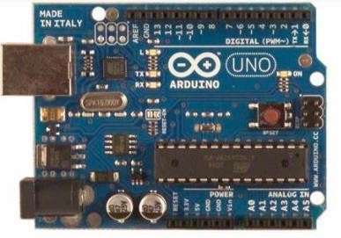The ATmega328P microprocessor is the foundation of the Arduino UNO. Compared to other boards, like the Arduino Mega board, etc., it is simple to use. The board is made up of shields, various circuits, and digital and analogue Input/Output (I/O) pins. The Arduino UNO comes with a USB port, a power jack, 14 digital pins, 6 analogue pin inputs, and an ICSP (In-Circuit Serial Programming) header. The programming language used is called IDE, or integrated development environment. It is compatible with offline and online platforms.

Fig.1 Arduino uno

b.GSM Module

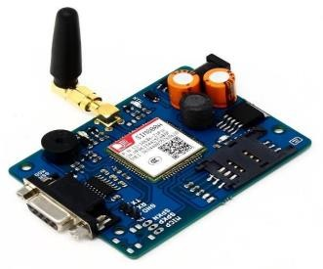The TTL SIM 900 is a full Quad-band GSM/GPRSGSM module that is used to send SMS to the user. Here, we've used a TTL SIM900 GSM module, which gives and takes TTL logic directly (user may use any GSM module).. Its operational voltage range is between 3.8 and 4.2 volts .

Fig.2 GSM module

c.Soil moisture sensor

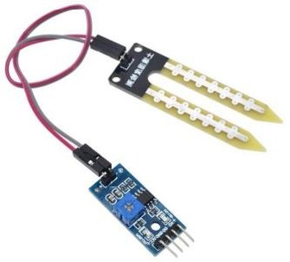A Soil Moisture Sensor is one kind of low-cost electronic sensor that is used to detect the moisture of the soil. This sensor can measure the volumetric content of water inside the soil. This sensor is consisting of mainly two parts, one is sensing Probs and another one is the sensor Module.

Fig.3 Soil moisture sensor

d.Water pump

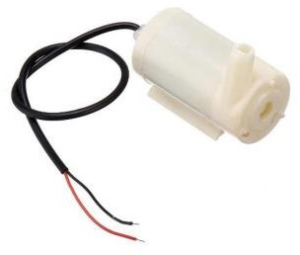The pump is used to create artificial water for a specific purpose. By connecting it to a microcontroller, it is frequently electronically controlled. It is frequently turned ON/OFF by sending signals to the Renata. Pumping is the process of moving water using artificial methods.

Fig.4 Water pump

e.Relay

Relay modules are simple building blocks. They essentially serve as switches . There are two channels in this relay module (those blue cubes). There are more variants with 1, 4, and 8 channels. In order to utilise this module with an Arduino, it should be powered by 5V.

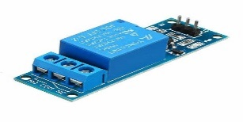

Fig.5 Relay module

f. LCD

The LCDs have a parallel interface, meaning that the microcontroller has to manipulate several interface pins at once to control the display.

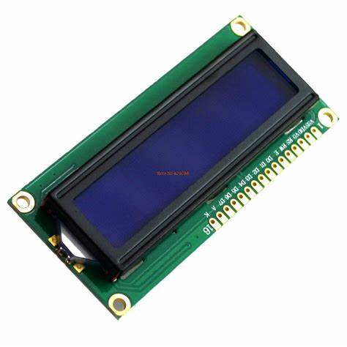

Fig.6 LCD display

g. Connecting wires

Connecting wires allows an electrical current to travel from one point on a circuit to another.

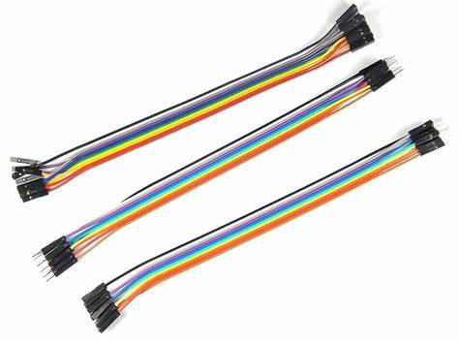

Fig. 7 Connecting wires(m-m,f-f,m-f)

SOFTWARE USED-

a.Arduino IDE

The open-source software known as the Arduino IDE is used to create and upload code to Arduino boards. For different operating systems, including Windows, Mac OS X, and Linux, the IDE program is appropriate. The programming languages C and C++ are supported. Integrated Development Environment is referred to in this sentence.

IV.METHODOLOGY

*a.Block Diagram of Smart Farm-Automatic plant watering System*

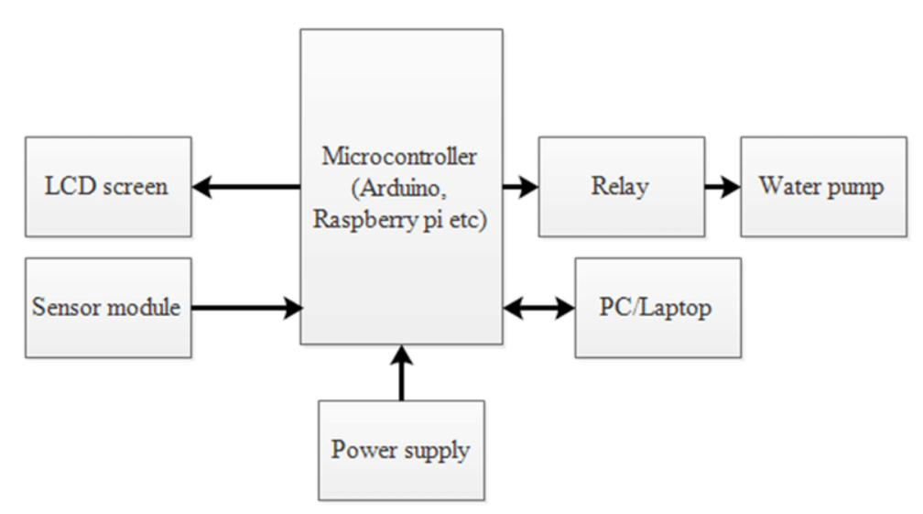Fig.8 Block diagram of Smart farm-Automatic

plant Watering System with message alert

Figure 8 shows the block diagram of the smart farm-automatic plant watering system.. This system consists of three hardware that is linked to the Arduino UNO which are the soil sensor, GSM module and the water pump.

*b.Flowchart of the Smart Irrigation System*

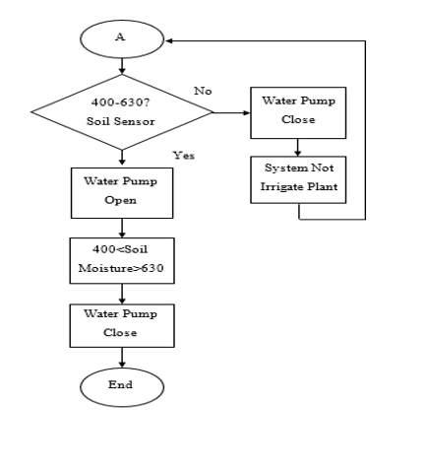Fig.9 Flowchart of Smart farm-Automatic plant Watering System with message alert

Figure 9 shows the working principle of smart farm-automatic plant watering system to measure the soil moisture.

This automatic plant irrigation system is very easy to use. First of all, the system is entirely automated, thus no human beings are required to operate it. The entire process is managed by an Arduino board, and a GSM module is utilized to deliver notifications to the user's cellphone.

When moisture is present in the soil, there is conduction between the two probes of the soil moisture sensor, and as a result, transistor Q2 continues to be activated/on and Arduino Pin D7 continues to be low. The message "Soil Moisture is Normal" is sent to the user by Arduino when it detects a LOW signal at D7. Water pump still in Off condition despite motor being turned OFF.

Transistor Q2 turns off and Pin D7 turns high if there is no moisture in the soil. The water motor is then turned on and a message stating "Low Soil Moisture detected" is sent to the user once Arduino reads Pin D7. Motor started to run. When the soil has enough moisture, the motor will automatically turn off.

*c . Program code*

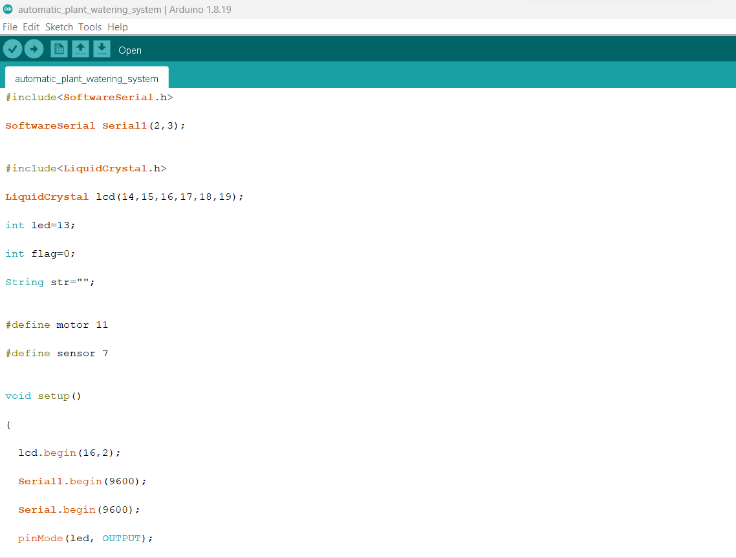

Fig.10 Program code of Smart farm-Automatic plant watering system with message alert

V.RESULTS AND DISCUSSIONS

For this part, there were experiments on normal irrigation and smart irrigation. After looking at the comparisons of the data, the next experiments were conducted using smart irrigation system. Every experiments were done for 7 days only in order to see the reactions on the leaves, stems, surroundings temperatures, humidity values and soil moisture values of the plant.

*a.Normal Irrigation System*

The soil moisture values in the normal irrigation experiment range from 557 to 610. This plant has grown only 20.39 percent in height since the experiment began. Approximately 75% of the plant's diameter grows. It may conclude that the plant is being overwatered. That is visible on the plant's leaves. There were yellow and brown hues around the plant's perimeter. It is a sign that the plant has been overwatered. This happens when there is too much water on the plant's roots, preventing the plant from breathing.

Table 1: Temperature, humidity and soil moisture of normal irrigation system.

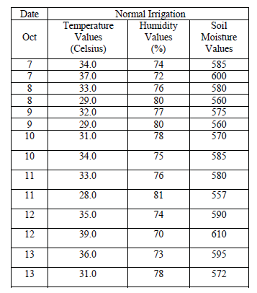

Table 2 : Measurement of height & diameter for normal irrigation system

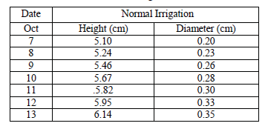

*b.Smart Irrigation System*

The soil moisture values in this smart farm-Automatic plant watering system experiment range from 506 to 601. This plant has grown 28.39 percent in height since the experiment began. The plant's diameter increased by approximately 100%. It can conclude that the plant is healthy plant. From the leave, it shows that the colour of the leave is very green and has only 1 or 2 brown dots. From the values of the soil moisture, the values of it are not too close to 630 and 400.

Table 3: Temperature, humidity and soil moisture of smart irrigation system

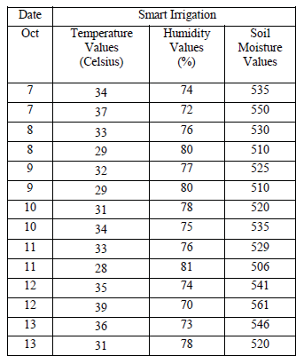

Table 4: Measurement of height & diameter for smart irrigation system

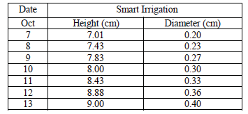

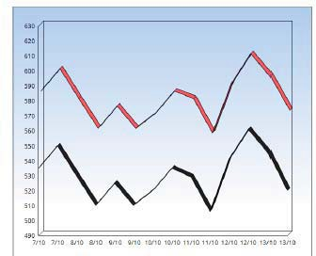c.Comparison of Normal and smart irrigation system

Fig. 11 Comparison of normal and smart irrigation system

We can manage the soil moisture content of farmed land thanks to this research. Water pumping motor was automatically turned on or off via a relay based on soil moisture. This increases crop output by saving water while obtaining the water level in a desired area of the plant. As a result, there is less water waste. Based on the type of plant, the soil's moisture level, and the recorded temperature, the system also enables distribution to the plant when necessary. Major agricultural regions' efforts are minimized by the suggested work.

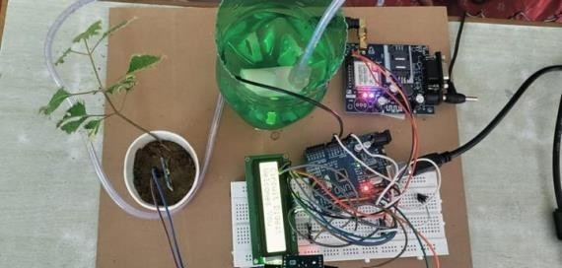

Fig.12 Prototype development

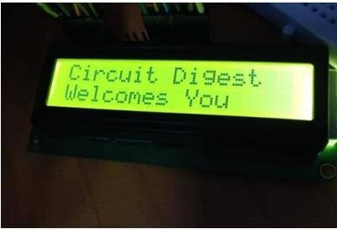

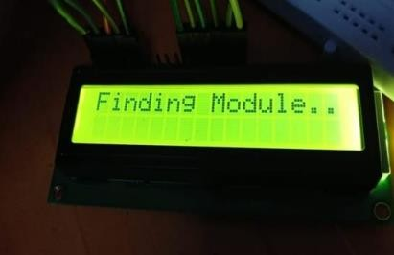 Fig. 13 LCD displaying message

Fig. 14 GSM Finding network



Fig. 15 Alert messages received by user

VI. CONCLUSION

This system uses an Arduino to measure and monitor essential elements like soil moisture and water availability for a crop. Thus, this approach improves farmers' comfort. Farmers can use this technology to learn about the field's surrounds and soil composition to determine which crops will yield the highest levels of productivity. As a result, less water is consumed.

The ultimate goal is to use a smart phone to analyse the soil condition of the plants in real time. The data is updated every 1 second and is extremely accurate.

VII. FUTURE SCOPE

It has been determined that this automated Smart Irrigation System employing IoT is cost-effective for upgrading the strategies, for conserving water resources and for making the most of them for agricultural productivity. This automated and intelligent system benefits the farmer. Water can only be supplied to the necessary area of land with the use of several sensors buried in the soil. Since this method requires less upkeep, all farmers may easily afford it. This technique significantly boosts crop productivity while also reducing water use. From a future standpoint, this system might be the more intelligent one that anticipates user behaviour, plant nutrition levels, harvesting times, etc.

VIII.REFERENCES

[1] B. D. Kumar, P. Srivastava, R. Agrawal and V. Tiwary “Microcontroller Based Automatic Plant Irrigation System,” International Research Journal of Engineering and Technology, vol. 04 no. 05, pp. 1436–1439, 2017.

[2] R. Kumar and H. R. Gautam, “Climate Change and its Impact on Agricultural Productivity in India,” Journal of Climatology and Weather Forecasting, vol. 2, no. 1, pp. 2–4, 2014.

[3] M. Giri and D.N. Wavhal, “Automated Intelligent Wireless Drip Irrigation Using Linear Programming,” International Journal of Advanced Research in Computer Engineering & Technology (IJARCET) vol. 2, no. 1, pp. 1–5, 2013.

[4] D. Bansal and S. R. N. Reddy, “WSN Based Closed Loop Automatic Irrigation System,” International Journal of Engineering Science and Innovative Technology (IJESIT), vol. 2, no. 3, pp. 229–237, 2013.

[5] Devika, C. M., K. Bose, and S. Vijayalekshmy. "Automatic plant irrigation system using Arduino." IEEE International Conference on Circuits and Systems (ICCS), Thiruvananthapuram, India 20-21 Dec,2017.

[6] M. Ramu and C. H. Rajendra, “Cost effective atomization of Indian agricultural system using 8051 microcontroller,” International Journal of Advanced Research in Computer and Communication Engineering, vol. 2, no. 7, pp. 2563-2566 , 2013.

[7] S. G. Zareen, K. S. Zarrin, A. R. Ali and S. D. Pingle “Intelligent Automatic Plant Irrigation System,”, International Journal of Scientific Research and Education, vol. 4, no. 11, pp. 6071–6077, 2016.

[8] R. Vagulabranan, M. Karthikeyan and V.

Sasikala, “Automatic Irrigation System on Sensing Soil Moisture Content,” Int. Res. J. Eng. Technol., vol. 3, no. 1, pp. 2012–2019, 2015.

[9] D. Mishra, A. Khan, R. Tiwary and S. Upadhay “Automated Irrigation System-IoT Based Approach,” 3rd International Conference On Internet of Things: Smart Innovation and Usages (IoT-SIU). IEEE, Bhimtal, India 23-24 Feb., 2018.

[10] A. Stesel and A. Osanlou, “A Sustainable Indoor Plant Production Management System with Wireless Internet Access,” Young Researchers in Electrical and Electronic Engineering (EIConRus), 2018 IEEE Conference of Russian IEEE Moscow, Russia 29 Jan.-1 Feb., 2018.

[11] “https: //en.wikipedia.org/wiki/NodeMCU.”.

[12]“https://circuitdigest.com/article/relay-working-types-operationapplications.”

[13] K. N. V Satyanarayana, S. R. N. Reddy, P. S. Teja and M. B. Habibuddin, “IOT Based Smart Weather Station Using RaspberryPI3,” Journal of Chemical and Pharmaceutical Sciences, no. 10, pp. 1– 6, 2016.

[14]“https://www.instructables.com/id/Interface-DHT11-Humidity-SensorUsing-NodeMCU/.”

[15]“https://www.instrumentchoice.com.au/emails/Monthly%20Newsletter/ 10-5-16/soil-moisture-sensors-and-how-they-work.”

[16]“https://www.globalspec.com/learnmore/flow_control_flow_transfer/p umps/dc_pumps.”

[17]“https://www.digikey.com/en/maker/blogs/2018/introduction-to-thearduino-ide.”

[18] “https://www.blynk.cc/.”

[19] P. Naik ,et al., “Arduino Based Automatic Irrigation System Using IoT,” International Journal of Scientific Research in Computer Science, Engineering and Information Technology (IJSRCSEIT ) vol. 2, no. 3, pp. 881–886, 2017.